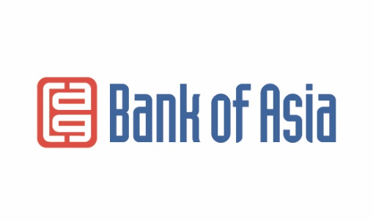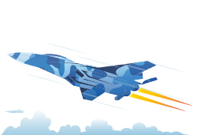

**Required documents for obtaining the Mig-100 loan**

* Passport
* Salary certificate or business document (patent, certificate, license). Confirmation of wages through an extract from the social Fund, if the certificate is not issued by a state institution
* Written consent of the spouse
* Certificate of availability of real estate

*The one parallel credit is allowed*

* The Bank reserves the right to request additional documents if necessary.